**EXPERIMENT – 9**

**AIM:** - Implementation of SUBNETTING in CISCO PACKET TRACER simulator.

**What is subnetting?**

Classless IP subnetting is a technique that allows for more efficient use of IP addresses by allowing for subnet masks that are not just the default masks for each IP class. This means that we can divide our IP address space into smaller subnets, which can be useful when we have a limited number of IP addresses but need to create multiple networks.

**OUTPUT: -**

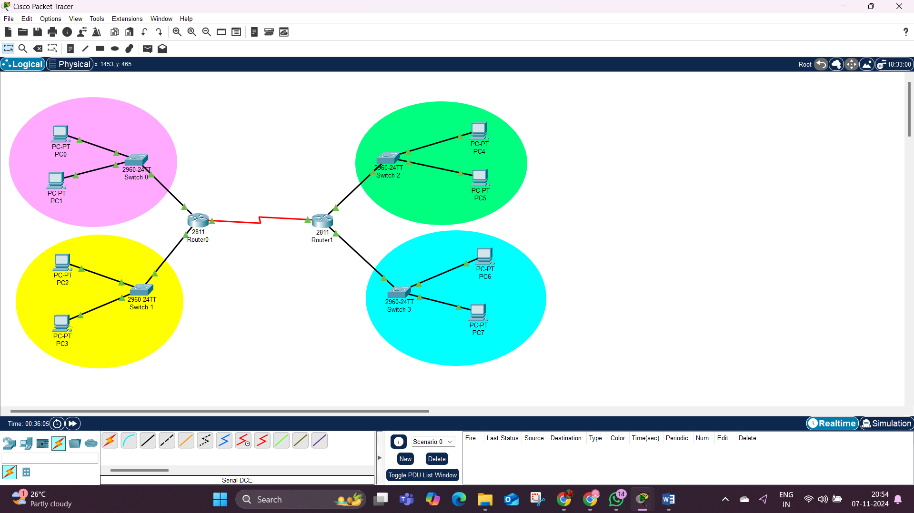

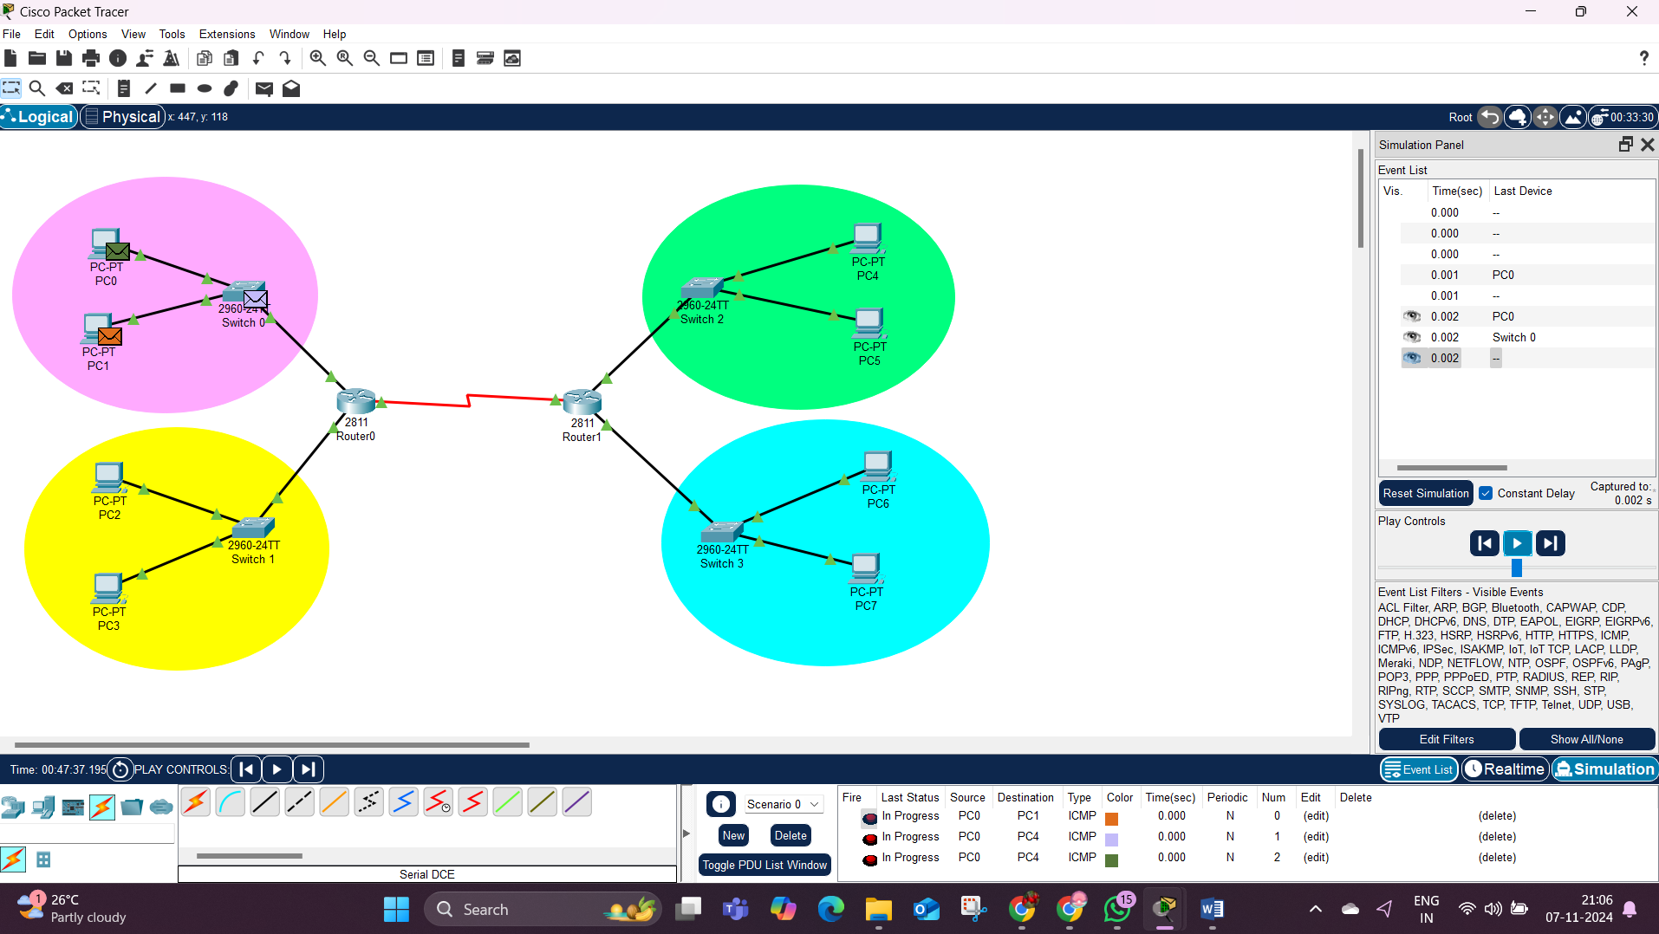

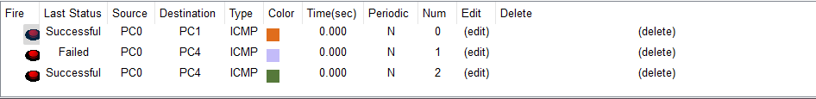

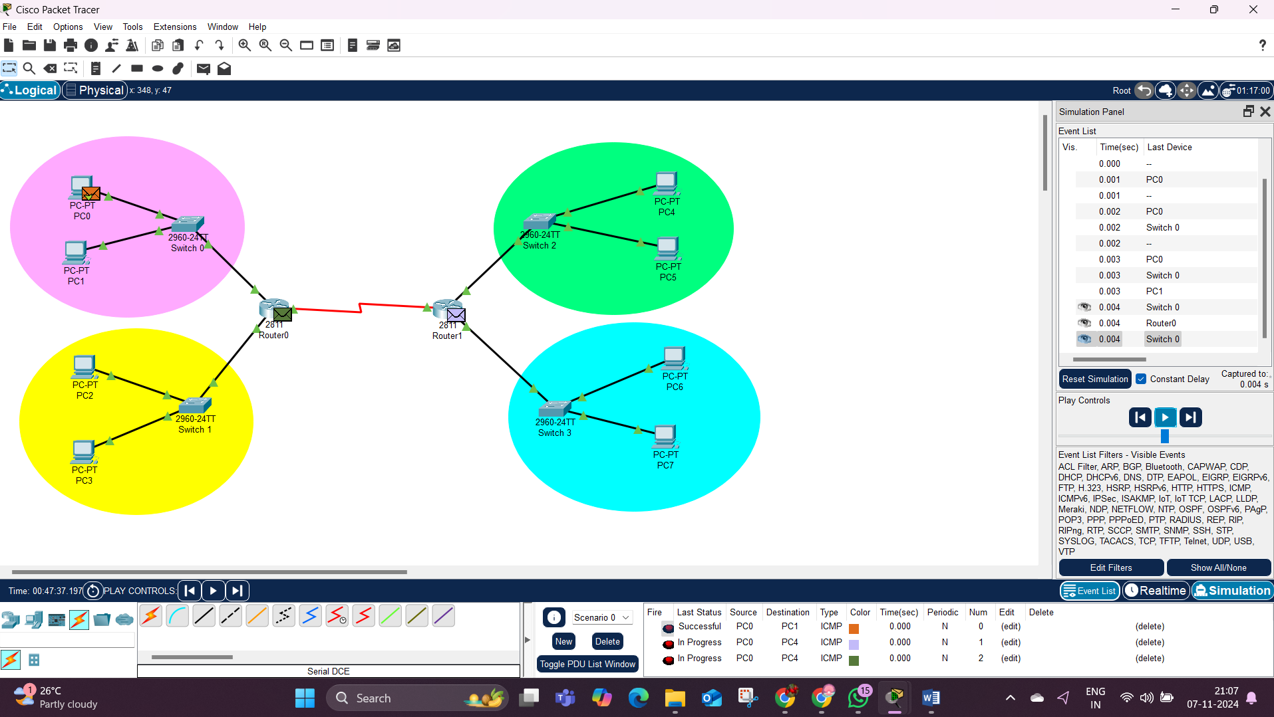

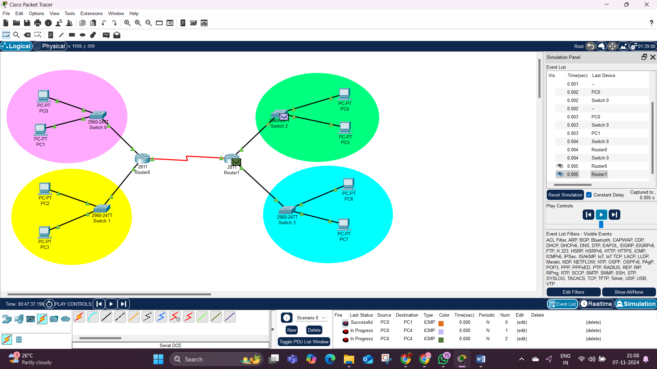

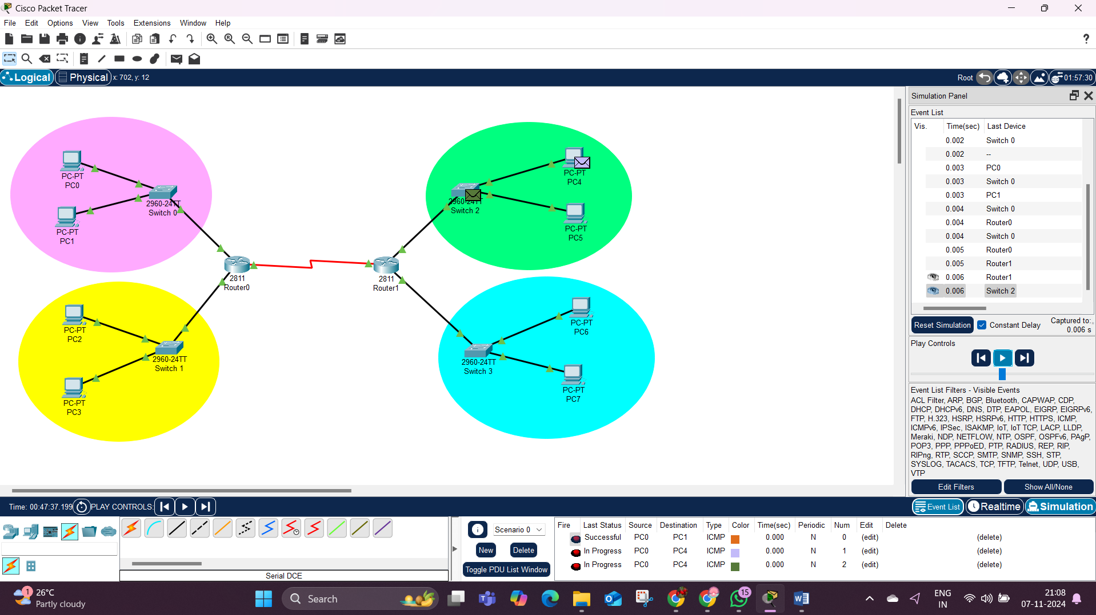

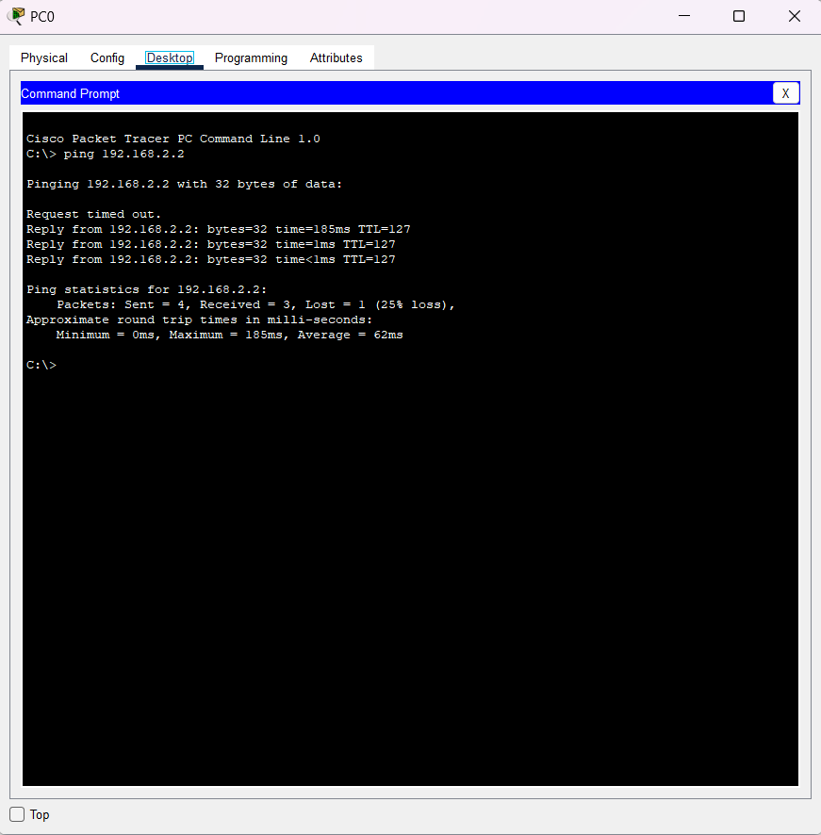

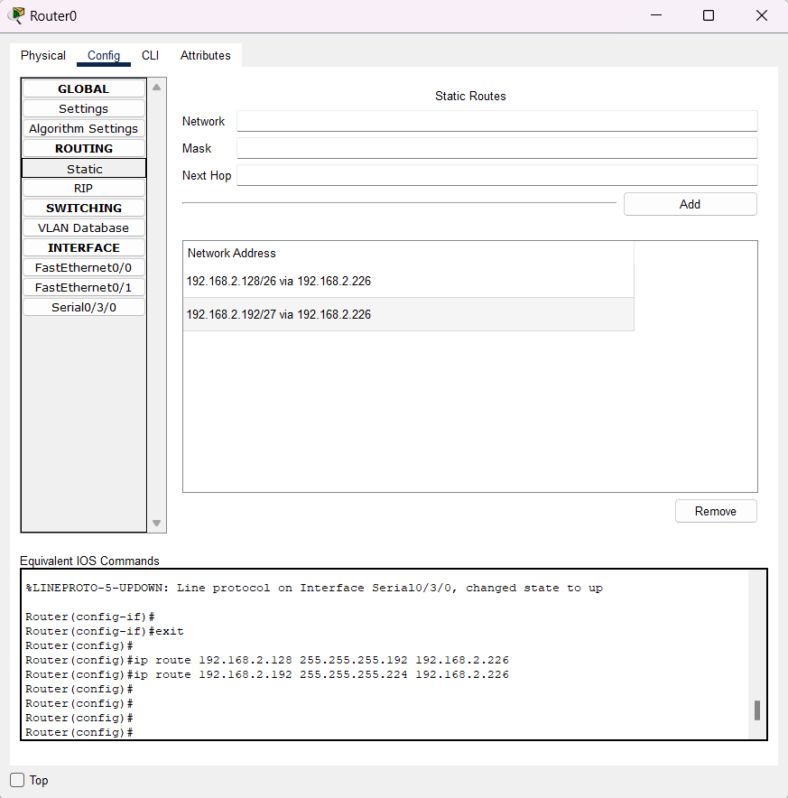

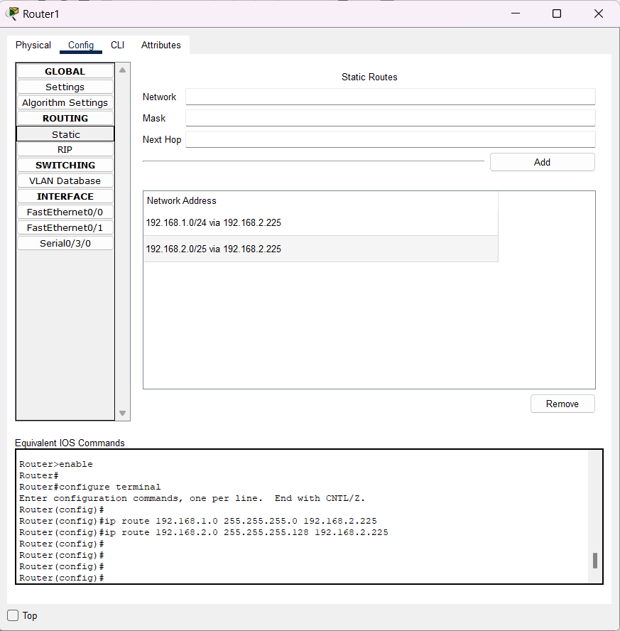

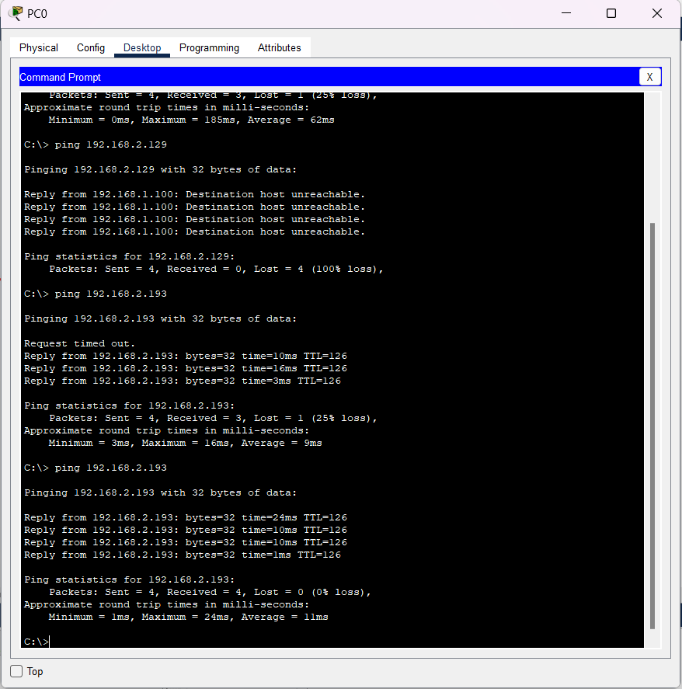

**RESULT: -**

Implementation of SUBNETTING in CISCO PACKET TRACER simulator have been done successfully